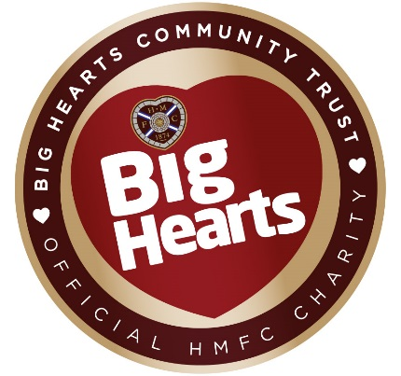

CHARITY REQUEST FORM
Thank you for your enquiry. Due to the number of donation requests Big Hearts and Heart of Midlothian Football Club receive we can only proceed with those which meet our criteria.
As such, we ask that those requesting an item to raise charitable funds, to submit the following form with a signed letter from your chosen charity on headed paper confirming they are in support of your fundraising.
On receipt of a completed application and signed letter we shall be able to proceed with your donation request. We aim to respond to all requests submitted in the correct form within a 4 to 6 week period.
About You
Name
Address
Email
Phone number

About your charity
Charity/Cause
Date of event
Type of event
Estimated number of people attending
Once this form is completed, please send it to Big Hearts:
- By email at: charityrequests@bighearts.org.uk
- Or by post at:
Charity Requests
Big Hearts Community Trust
Tynecastle Stadium, Gorgie Road
Edinburgh
EH11 2NL

